***Customer Churn Analysis Report***

**Introduction:**

The data set belongs to a leading online E-Commerce company. In the dynamic world of online retail, customer retention is paramount for success. As a leading E-commerce company, we are committed to understanding and mitigating customer churn. This dataset analysis is a pivotal step in identifying key factors influencing churn and devising effective strategies to keep our valued customers engaged and satisfied.

**Customer Churn**: Customer churn, also known as the churn rate, represents the rate at which customers discontinue their association with a business relative to the total number of active customers.

**Problem statement**

Our main aim with this data analysis is to find out why some of our customers are leaving our online store. We want to look at the information in this dataset to figure out what makes them go away. By doing this, we hope to learn useful things that can help us keep our customers happy and stop them from leaving. In the end, we want our customers to stay with us for a long time and have a good relationship with our online store.

**Data Overview:**

We started our analysis with a dataset containing 5630 rows, provided in the form of a CSV file. Leveraging the power of Power BI and Power Query, we embarked on our journey to uncover key insights.

**Data Cleaning and Formation;**

We cleaned data in following manner

1. Preferred payment mode duplicates removed
2. Column names settled
3. Order amount hike column data type changed to Percentage
4. Conditional column added against “Tenure”
5. A separate column added for Churned and Not Churned customers.

**Objectives**

In this project, we are going to analyze:

● Number of churn and retained customer across various attributes/dimensions

● Explore the reasons behind customer churn

● What necessary actions can you take to help the company reduce its churn rate.

**Research Questions:**

1.What is the overall churn rate for the mobile app? Calculate the percentage of customers who have churned.

2.Do customers with longer tenure tend to churn less? Calculate the average tenure for both churned and retained customers and visualize it.

3.Does customer satisfaction score correlate with churn? Calculate the average satisfaction score for both churned and retained customers

4.Are customers who place more orders less likely to churn? Calculate the average order count for both churned and retained customers and visualize it to gather insights.

5.Are there any differences in churn rates based on the preferred payment mode?

**1. Overall Churn Ratio Analysis**

**Insights:**

* Churned Customers: 17%
* Retained Customers: 83%

First of all we analyzed the customer wise churn rates which enlightened us with a satisfaction of 83% customer retention rate. Only 17% of the customers left us which is 948 customers out of 5630 in numbers.

Still we need to find out the reasons of the churned customers and need to retain them for the sake of prosperity of our business.

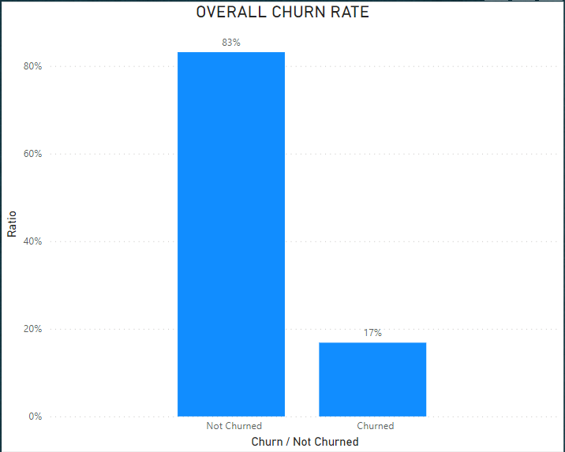

**Recommendations:**

* **Customer Engagement Initiatives**: Implement personalized marketing campaigns, loyalty programs, and enhanced customer service to retain existing customers.
* **Product/Service Enhancement:** Continuously improve our offerings based on customer feedback and market trends.
* **Communication:** Maintain effective communication with customers to strengthen relationships and reduce churn.
* **Root Cause Analysis:** Dive deeper to identify the reasons behind customer churn. Are there issues with network quality, customer service, pricing, or competition? Collect customer feedback through surveys or complaints data to pinpoint the root causes.
* **Customer Experience Improvement:** Focus on improving the overall customer experience. Satisfied customers are less likely to churn. Monitor and address pain points in the customer journey.
* **Customer Feedback/complains:** Actively seek and act upon customer feedback. Listening to your customers can provide valuable insights into their needs and preferences.

**2. Average Tenure of Churned/Retained customers.**

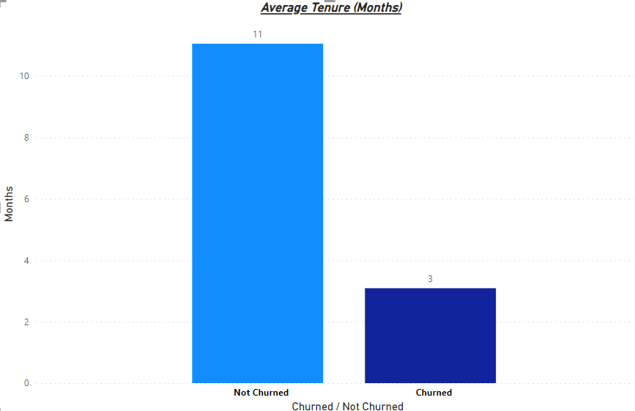

The data about customer tenure reflects that, on average, churned customers stayed with the company for only 3 months on average, while customers who didn't churned stayed for an average of 11 months. This indicates that the company is struggling to retain customers for a longer period, as they aren't staying for even a year on average.

It is really alarming situation for the company. As in previous analysis we got to know that churn rate is only 17% but current analysis is an eye opener that even churn rate is comparatively low but it seems company is unable to retain new customers with it. If customers are not staying with us even a year it suggests to analyze overall products quality, services and our online platform user interface analysis.

**Insights:**

* Churned Customers: Average Tenure - 3 months
* Retained Customers: Average Tenure - 11 months.

Churned customers have a significantly shorter average tenure, indicating a rapid loss of customers.

**Recommendations:**

* **Long-Term Value Proposition:** Emphasize the long-term benefits of staying with us.
* **Retention Programs:** Implement customer retention programs that offer incentives or rewards for staying with the company.
* **Customer Engagement:** Increase efforts to engage and communicate with customers regularly to build loyalty.
* **Quality of Service:** Ensure the quality of products and services is high to reduce dissatisfaction and encourage long-term loyalty.

**3. Does Customer Satisfaction Score Correlate with Churn?**

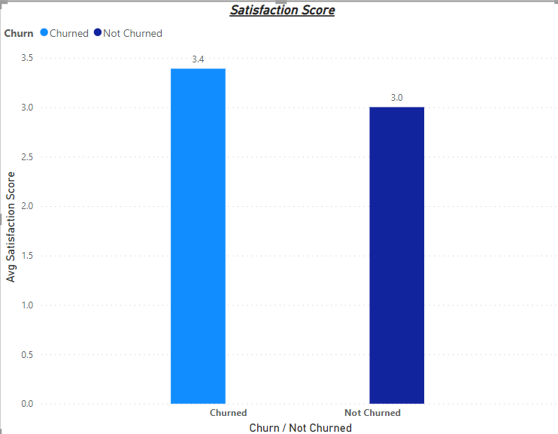

**Insights:**

* Average Satisfaction Score: 3.1
* 23% of 5-star-rated customers churned.

Churned customers gave higher satisfaction scores (3.4) than retained customers (3.0).

The average customer satisfaction score for the company is 3.1, which is not very high, indicating there is room for improvement in customer satisfaction.

Out of the customers who gave a 5-star rating, 23% of them churned. This suggests that high satisfaction ratings do not necessarily guarantee customer retention.

Churned customers actually gave higher satisfaction scores (3.4) compared to not churned customers (3.0). This indicates that while customers may be happy with the products, there are other issues not being addressed that lead to churn.

Based on the provided data, customer satisfaction scores do not strongly correlate with churn, there might be some relationship between satisfaction scores and churn, it is not a strong or direct correlation. Other factors and issues are likely contributing to customer churn, and it's important to investigate and address these factors separately to improve customer retention

If we further analyze 1801 customer are with us for above one year and they gave us 3.08 stars which is not so good. Which further indicates that the customers with us above the average tenure (11 Months) are also not very satisfied with the products but they are using our application due to any other reason.

**Recommendations**

**Dig Deeper:** Investigate the specific issues or reasons that lead to churn despite high satisfaction scores. Conduct surveys or gather feedback to identify these hidden problems.

**Customer Support:** Focus on improving customer service and support to address the issues that are causing churn, even for satisfied customers.

**Retention Strategies:** Develop retention strategies that go beyond satisfaction scores and address the underlying factors contributing to churn.

**Continuous Quality Improvement:** Focus on improving product or service quality.

**Benchmarking:** Compare satisfaction scores with industry benchmarks.

In summary, while high satisfaction scores are positive, they don't guarantee customer retention. There may be underlying issues causing churn that need to be addressed through improved customer support and retention strategies.

### **4. Are customers who place more orders less likely to churn?**

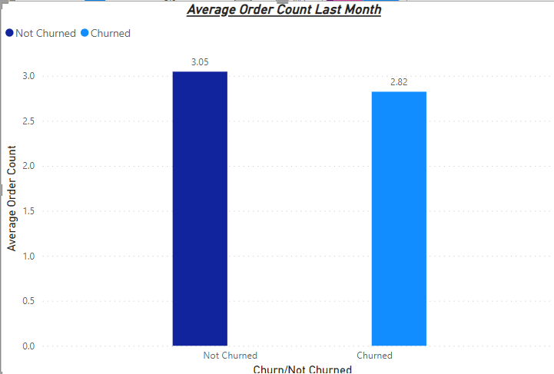

The data provided, which includes the order count for both churned and retained customers, does give some insights into customer behavior, but it may not directly correlate with churn for the reasons you mentioned (i.e., it's based on the last month's data, and churned customers might have left before then).

**Insights:**

* Churned Customers: Average Orders - 2.8
* Retained Customers: Average Orders - 3.0

Churned customers placed slightly fewer orders in the last month. Though churned customers placed slightly fewer orders, the limitations of historical data left us with questions.

**Recommendations:**

* **Historical Data:** To analyze churn more effectively, it's crucial to have access to historical data that includes when customers churned. This will allow for a more accurate assessment of the relationship between order counts and churn.
* **Customer Segmentation:** Consider segmenting customers based on their order history, tenure, and other factors to better understand what leads to churn and which customer groups are more at risk.
* **Comprehensive Analysis**: Look beyond just order counts and analyze other factors like customer satisfaction, contract types, pricing, and customer support interactions to identify the key drivers of churn.

### **5. Churn Rate and Different Payment Modes:**

**Insights:**

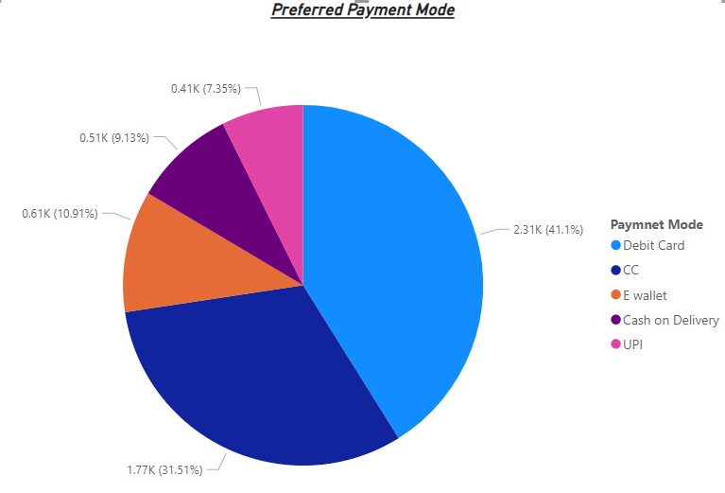

Debit Card is the most widely used payment mode overall, with 41% of total customers preferring it.

Credit Card is the second most popular payment mode, chosen by 32% of users.

Among churned customers, 37% preferred Debit Cards, indicating that a significant portion of churned customers used this payment mode.

**Recommendations**

**Payment Mode Analysis:** Continue monitoring payment mode preferences among churned and retained customers to see if this trend persists over time.

**Segmentation:** Segment customers based on their payment preferences and analyze whether there are specific payment modes associated with higher churn rates.

**Retention Strategies:** Develop targeted retention strategies for customers who prefer Debit Cards or other payment modes with higher churn rates to address their specific needs and concerns.

**Customer Engagement:** Engage with customers who prefer different payment modes through tailored communications and offers to improve their loyalty.

**Diversify Payment Options:** Consider offering incentives or discounts for using payment modes that have lower churn rates to encourage more customers to adopt those methods.

In summary, while there is a notable association between payment mode and churn in this data, further analysis and targeted retention strategies are needed to understand the underlying reasons and take appropriate actions to reduce churn effectively.

**7.Connecting the Dots:**

* Churned customers tend to have a shorter tenure, higher complaints, and a slightly lower average order count.
* While most of our customers are male, we must explore whether differences in tenure and complaint rates are gender related.

**Conclusion**

Our journey through this data-driven analysis has illuminated various facets of customer churn. It's clear that enhancing customer engagement, addressing pain points, and continuously improving our offerings are vital steps towards reducing churn. Moreover, understanding the nuanced relationship between satisfaction, order behaviour, and payment preferences will be key to our success.

We must continue to monitor these factors and implement the recommended strategies to bolster our customer retention efforts. As we navigate the e-commerce landscape, these insights will guide us toward stronger customer relationships and a brighter future.Top of Form